A PROJECT TITLE

ON

Patient Segmentation Using K-Means and Hierarchical Clustering for Healthcare Analytics

project report submitted in partial fulfilment of the requirements for the Course

MACHINE LEARNING

BACHELOR OF TECHNOLOGY

In

A.Y.: 2026-27

By

Charan Teja – Roll No. 2520030031

Nikhitha – Roll No. 2520030033

Samshritha – Roll No. 2520030045

Under the Esteemed guidance of

Dr.N.Nirmalajyothi

Associate Professor, CSE

Department of Computer Science and Engineering





Abstract
This project applies unsupervised machine learning to segment patients into groups with similar characteristics when no predefined labels are available. A healthcare dataset of 2,000 patient records and 16 features, covering demographics, physical measurements, healthcare utilization, billing and preventive-care behaviour, is cleaned and preprocessed using median/most-frequent imputation, one-hot encoding of categorical variables and standardization of numerical features. K-Means clustering is used to form patient groups, and Agglomerative Hierarchical Clustering with Ward linkage provides a second approach for comparison. The Elbow Method and the Silhouette Score are used to evaluate candidate cluster counts, while PCA and a dendrogram are used to visualize the clustering structure. Both algorithms produce two clusters in the tested configuration; K-Means attains a Silhouette Score of 0.1270 against 0.0996 for Hierarchical Clustering. The K-Means profiles separate a younger, lower-utilization group (average age 35.90 years, 3.12 annual visits) from an older, higher-utilization group (average age 59.35 years, 5.67 annual visits). The low scores indicate overlapping, broad data-driven segments rather than sharply separated clinical categories.
Keywords: Patient Segmentation, K-Means Clustering, Hierarchical Clustering, Silhouette Score, Healthcare Analytics, Unsupervised Learning

1. Introduction

1.1 Purpose of the Project
Hospitals and clinics now record large volumes of patient information such as age, body measurements, chronic conditions, number of visits, billing amounts and preventive-care use. Treating every patient with the same plan is rarely efficient, because patients differ widely in their health needs and in how they use services. Patient segmentation, the task of grouping patients with similar characteristics, helps hospital administrators, care managers, insurers and health-policy analysts to understand the population they serve and to plan resources, outreach and preventive programmes more sensibly [1], [4].
Predefined labels such as 'high-risk' or 'low-risk' are often unavailable in routine healthcare data, and building them manually requires clinical effort and time. This creates a clear need for unsupervised machine learning, which can discover natural groups directly from the data without labels. A data-driven segmentation of this kind gives stakeholders an objective, repeatable starting point for analysis and reporting; it is not a substitute for clinical judgement.

1.2 Problem Statement
The problem addressed in this project is an unsupervised clustering problem. Given a dataset of 2,000 patient records described by demographic (age, gender, state), physical (height, weight, BMI), clinical (chronic conditions, primary condition), utilization (annual visits, days since last visit), financial (average billing, insurance type) and preventive-care features, the goal is to discover natural groups of similar patients without any predefined cluster labels. The expected output is a cluster label for each patient, an evaluation of cluster quality using the Silhouette Score, and an interpretable profile of every cluster.

1.3 Existing Methods and Disadvantages
Most healthcare machine-learning studies rely on supervised models that need diagnostic labels, and these models are prone to overfitting and cannot be applied when labels are absent or limited [9]. Where clustering has been used, K-Means remains the dominant choice in healthcare informatics because it is simple and efficient, and comparative studies on electronic health records report it as a strong performer, with Hierarchical Clustering close behind [1], [9]. However, many reported studies apply a single algorithm to a narrow set of variables, for example only vital signs and demographics [4] or only visit patterns [5], and therefore describe patients from one angle only.
Existing approaches also have well-known limitations. K-Means requires the number of clusters to be fixed in advance, is sensitive to feature scaling and initialization, and prefers compact, roughly spherical groups; Hierarchical Clustering does not need K up front but is computationally heavier on large datasets. More advanced deep-learning and ensemble clustering methods can improve results on some cohorts but need more data, tuning and computing time, and are harder to interpret, while traditional methods were found to remain competitive on tabular healthcare data [3], [7], [9]. Mixed numerical and categorical patient data adds a further difficulty, because distance-based methods can be distorted if raw categories and inconsistent scales are not handled properly.

1.4 Proposed System
The proposed system is an end-to-end unsupervised pipeline for patient segmentation. The CSV dataset is loaded and the PatientID column is treated as an identifier and excluded from clustering. Missing values are imputed with the median for numerical features and the most frequent value for categorical features; categorical variables are one-hot encoded and numerical variables are standardized so that all features contribute fairly to distance calculations. K-Means and Agglomerative Hierarchical Clustering (Ward linkage) are then applied, the number of clusters is guided by the Elbow Method and the Silhouette Score, and the clusters are visualized using PCA and a dendrogram. The main contribution is a side-by-side comparison of the two algorithms on the same preprocessed data together with readable cluster profiles for age, BMI, chronic conditions, visits, billing and preventive-care behaviour.

1.5 Research Objectives
- Prepare and clean the patient dataset (2,000 records, 16 columns) for clustering.
- Perform systematic preprocessing: missing-value imputation, one-hot encoding of categorical variables and standardization of numerical variables.
- Explore the main patient characteristics (age, BMI and healthcare-utilization measures) before clustering.
- Apply K-Means and Hierarchical (Ward) Clustering to segment the patients.
- Evaluate and compare the two algorithms using the Elbow Method and the Silhouette Score, and visualize the structure with PCA and a dendrogram.
- Interpret the resulting clusters through feature-wise profiles and discuss their practical applicability and limitations.

2. Literature Survey
Ten recent studies (2024 to 2026) on patient clustering and segmentation from electronic health records and clinical data are reviewed below. The studies were selected for their direct relevance to K-Means, Hierarchical and related clustering of patient data.
S.No. | Title | Reference with DOI | Problem or gap addressed | Objective of the Research | Focus of the paper (Methods used) | Inference | Recommendations for future research
1 | Optimizing patient stratification in healthcare: a comparative analysis of clustering algorithms for EHR data | A. Aljohani, Int. J. Comput. Intell. Syst., vol. 17, no. 1, Art. 173, 2024. doi: 10.1007/s44196-024-00568-8 | Choosing a suitable clustering algorithm for patient stratification from EHR data. | Compare clustering algorithms for EHR patient grouping. | K-Means, DBSCAN, Hierarchical, Mean Shift, Affinity Propagation, Spectral, GMM, ranked with Fuzzy TOPSIS. | K-Means ranked best overall; Hierarchical Clustering ranked second. | Extend the comparison to more datasets and ranking criteria.
2 | Detecting cardiovascular diseases using unsupervised machine learning clustering based on electronic medical records | Y. Hu et al., BMC Med. Res. Methodol., vol. 24, Art. 309, 2024. doi: 10.1186/s12874-024-02422-z | CVD prediction models are often built on community populations; unsupervised detection in hospital settings is less explored. | Build an unsupervised model to detect prevalent CVD from EMR data. | K-Means with 2, 4 and 8 clusters plus Bayesian theorem on hospital EMR and laboratory data. | EMR data can support a robust CVD detection model through unsupervised ML. | Longitudinal design to refine the model for clinical use.
3 | M-ClustEHR: a multimodal clustering approach for electronic health records | M. Bampa et al., Artif. Intell. Med., vol. 154, Art. 102905, 2024. doi: 10.1016/j.artmed.2024.102905 | Sepsis outcomes depend on comorbidities; EHR data of several types is hard to cluster jointly. | Identify sepsis patient phenotypes from multimodal EHR data. | Multimodal autoencoder for patient representation followed by clustering on MIMIC-III. | Outperformed traditional clustering on internal metrics and stability; 26 phenotypes found. | Validate phenotypes on other cohorts and with clinicians.
4 | Segmentasi pasien berbasis K-Means dari tanda-tanda vital dan demografi | R. Afriany, R. Sinaga, Samsinar, JUISIK, vol. 5, no. 3, pp. 638-650, 2025. doi: 10.55606/juisik.v5i3.1811 | Clinical data is under-used for evidence-based decisions in hospitals. | Segment outpatients using vital signs and demographics. | K-Means on 1,401 outpatient records after standardization, with PCA for visualization. | K-Means effectively revealed latent risk patterns in the patient population. | Add more clinical variables and compare other algorithms.
5 | Segmentasi pasien rumah sakit berdasarkan pola kunjungan menggunakan algoritma K-Means clustering | Y. G. Nengsih, K. Samosir, B. Satria, J. Pendidik. Sains Komput., vol. 5, no. 1, pp. 59-69, 2025. | Hospitals face diverse patient flows by visit time, frequency and service type. | Segment patients by visit pattern to optimize services. | K-Means (RapidMiner) on age, gender, annual visits, visit duration, care type and diagnosis. | Patients fell into three groups: chronic, routine and incidental. | Include richer clinical and cost features.
6 | From patterns to prognosis: machine learning-derived clusters in advanced heart failure | M. Karacam et al., Front. Cardiovasc. Med., vol. 12, Art. 1669538, 2025. doi: 10.3389/fcvm.2025.1669538 | Advanced heart failure is heterogeneous and standard classifications miss this. | Find phenotypic subgroups and link them to outcomes. | Unsupervised clustering of 524 patients; k chosen with elbow and silhouette methods. | Two phenotypes found; Cluster 2 had a much higher risk of the composite outcome. | Validate the phenotypes in larger independent cohorts.
7 | Deep representation learning for clustering longitudinal survival data from electronic health records | J. Qiu et al., Nat. Commun., vol. 16, Art. 2534, 2025. doi: 10.1038/s41467-025-56625-z | Longitudinal EHR trajectories and time-to-event data are rarely used for defining patient clusters. | Cluster patients using trajectories and survival outcomes. | VaDeSC-EHR: transformer-based variational autoencoder; compared with K-Means and survival models. | VaDeSC-EHR outperformed baseline methods on synthetic data. | Test on further real-world EHR cohorts.
8 | clustra: a multi-platform k-means algorithm for longitudinal trajectories in large EHR data | N. Adhikari et al., arXiv:2507.00962, 2025. | Repeated measurements in EHR are hard to summarize at a single time point. | Cluster longitudinal trajectories at scale. | K-Means with thin-plate regression splines (R package and SAS macros); silhouette plots for choosing the cluster number. | K-Means can be scaled to large EHR trajectories with silhouette-based diagnostics. | Wider use on other clinical measurements.
9 | Mining electronic health records to investigate effectiveness of ensemble deep clustering | M. D. Samad, Y. Hou, S. Ghosh, arXiv:2604.07085, 2026. | Healthcare clustering is mostly traditional (K-Means); deep clustering is rarely tested on tabular EHR. | Compare traditional, hybrid and deep clustering for heart-failure cohorts. | 14 methods incl. K-Means, GMM, autoencoder and deep clustering, plus an ensemble, on All of Us data. | K-Means stays a strong baseline; the ensemble gave the best overall rank. | Evaluate on other cohorts and on heart-failure subtypes.
10 | Using K-means clustering to identify physician clusters by EHR burden and efficiency | J. Sim et al., Telemed. e-Health, vol. 30, no. 2, 2024. doi: 10.1089/tmj.2023.0167 | EHR documentation burden is a major problem, but physician workload patterns are not well profiled. | Group physicians by EHR burden and efficiency. | K-Means on six EHR-usage metrics, analysed by sex and specialty. | Two clusters: higher efficiency with less after-hours work, and the reverse. | Add more usage metrics and other health systems.

3. Methodology

3.1 Proposed System Flow Diagram
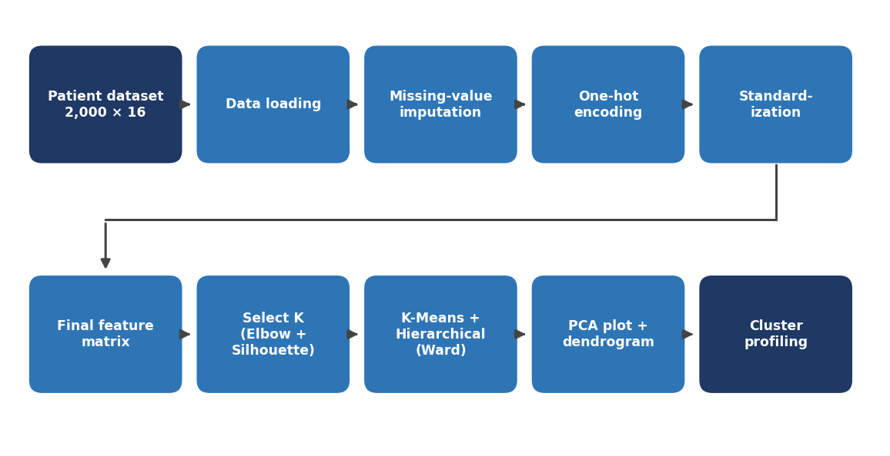
Figure 3.1: Proposed system flow diagram for patient segmentation
The pipeline starts with the patient dataset and passes through loading, missing-value imputation, one-hot encoding and standardization to create the final feature matrix. The number of clusters is then guided by the Elbow Method and the Silhouette Score, K-Means and Hierarchical (Ward) clustering are applied, the structure is visualized with PCA and a dendrogram, and the resulting clusters are profiled and interpreted.

3.2 Dataset Description
The experiments use patient_segmentation_dataset.csv, which contains 2,000 patient records described by 16 columns. The main numerical features are Age, Height, Weight, BMI, number of chronic conditions, annual visits, average billing amount, days since last visit and a preventive-care flag. The categorical features are Gender, State, Insurance type and Primary condition. PatientID is an identifier and is not used for clustering. The task is unsupervised, so the dataset has no target column and no predefined cluster labels.

3.3 Experimental Setup
The project was implemented in Python using a Jupyter-style notebook environment. The main libraries are pandas and NumPy for data handling, scikit-learn for imputation, encoding, scaling, K-Means, Agglomerative Clustering, PCA and the Silhouette Score, SciPy for the dendrogram, and Matplotlib for plots.

3.4 Data Preprocessing
- Data loading and inspection: the CSV file was read, giving 2,000 records and 16 columns.
- Identifier handling: PatientID is treated as an identifier and excluded from the clustering features.
- Missing-value imputation: median for numerical features and most-frequent value for categorical features.
- Categorical encoding: one-hot encoding of Gender, State, Insurance type and Primary condition.
- Numerical scaling: standardization (zero mean, unit variance), because clustering is distance-based and unequal scales would distort similarity.
- Model input: the encoded and scaled variables are combined into the final feature matrix used by both algorithms.
- Labels and data splitting: no target labels exist, so no train/test split is required and all 2,000 records are clustered; this also means there is no target leakage.

3.5 Exploratory Data Analysis
Exploratory analysis was carried out before clustering to understand the distributions of the main features. The patients cover a broad adult age range, and BMI provides a physical-health feature that contributes to patient similarity. Annual visits, average billing and days since last visit describe healthcare-use patterns. This step helps to spot skewed distributions and likely patterns before clustering.

3.6 Feature Engineering and Feature Selection
No new features were derived. All numerical features and the one-hot encoded categorical features were used, and PatientID was the only column removed because it identifies a patient but does not describe one. Standardization was the only transformation applied to numerical features. PCA was used only to visualize the clusters in two dimensions and not as input to the clustering models. Height, Weight and BMI are mathematically related, so they carry overlapping information; this is noted as a limitation in Section 4.3.

3.7 Model Building and Training
Two unsupervised models were built on the same feature matrix. K-Means chooses K cluster centres, assigns each patient to the nearest centre and recalculates the centres iteratively until the assignments stabilize; it minimizes the within-cluster sum of squared distances and is efficient for large datasets. Agglomerative Hierarchical Clustering starts with every patient as its own group and repeatedly merges the two most similar groups; Ward linkage was used, which merges the pair that increases the within-cluster variance the least. A dendrogram visualizes this hierarchy. Since the problem is unsupervised, there is no loss on labels and no separate validation set; quality is judged with internal measures. K = 2 was used for both models so that they can be compared directly.

3.8 Hyperparameter Tuning
The only key hyperparameter is the number of clusters K. Different candidate values of K were examined with the Elbow Method (the point where the decrease in within-cluster variance slows down) and the Silhouette Score (higher is better). In the tested configuration the scores selected K = 2 for K-Means, and the same K = 2 was used for Hierarchical Clustering. Grid search and cross-validation do not apply because no labelled target exists.

3.9 Model Evaluation
Classification and regression metrics (accuracy, precision, recall, F1-score, ROC-AUC, MAE, RMSE, R²) are not applicable because there are no ground-truth labels. The clusters are evaluated with the Silhouette Score, s(i) = (b(i) - a(i)) / max(a(i), b(i)), where a(i) is the average distance from patient i to the other patients in its own cluster and b(i) is the average distance to the patients of the nearest other cluster. The score lies between -1 and +1: values near +1 mean well-separated clusters, values near 0 mean overlapping clusters, and negative values suggest wrongly assigned points. The Elbow Method, PCA plot and dendrogram support the visual evaluation, and cluster profiles (feature-wise averages) are used for interpretation.

4. Results and Discussion

4.1 Preprocessing Results
The dataset initially had 2,000 records and 16 columns. Missing values were filled with the median (numerical features) or the most frequent value (categorical features), so no records had to be dropped and all 2,000 patients remained available for clustering. Categorical variables were one-hot encoded and numerical variables were standardized, producing the final feature matrix for the models.

4.2 Model Performance
Table 4.1: Comparison of the two clustering algorithms (Silhouette Score)
Model | Approach | Clusters (K) | Linkage | Silhouette Score | Rank
K-Means | Centroid-based | 2 | Not applicable | 0.1270 | 1
Hierarchical | Agglomerative | 2 | Ward | 0.0996 | 2
Both algorithms produced two clusters in the final configuration. K-Means achieved the higher Silhouette Score (0.1270 against 0.0996). Accuracy, precision, recall, F1-score and ROC-AUC are not reported because the project is unsupervised and has no ground-truth labels.
Table 4.2: K-Means cluster profiles (average feature values)
Feature | Cluster 0 (Avg.) | Cluster 1 (Avg.)
Average Age | 35.90 | 59.35
Height (cm) | 169.90 | 166.74
Weight (kg) | 81.86 | 87.06
BMI | 28.88 | 31.82
Chronic Conditions | 1.42 | 2.31
Annual Visits | 3.12 | 5.67
Avg. Billing | 3420.15 | 5287.43
Days Since Last Visit | 78.62 | 142.36
Preventive Care Flag | 0.38 | 0.21

4.3 Visual Results and discussion
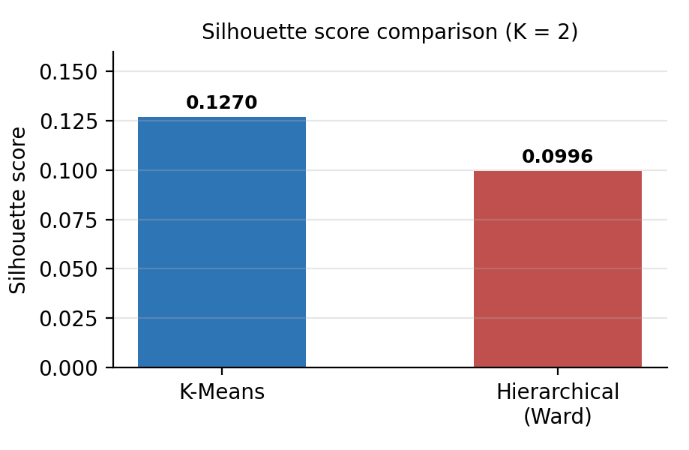
Figure 4.1: Silhouette Score of K-Means and Hierarchical Clustering
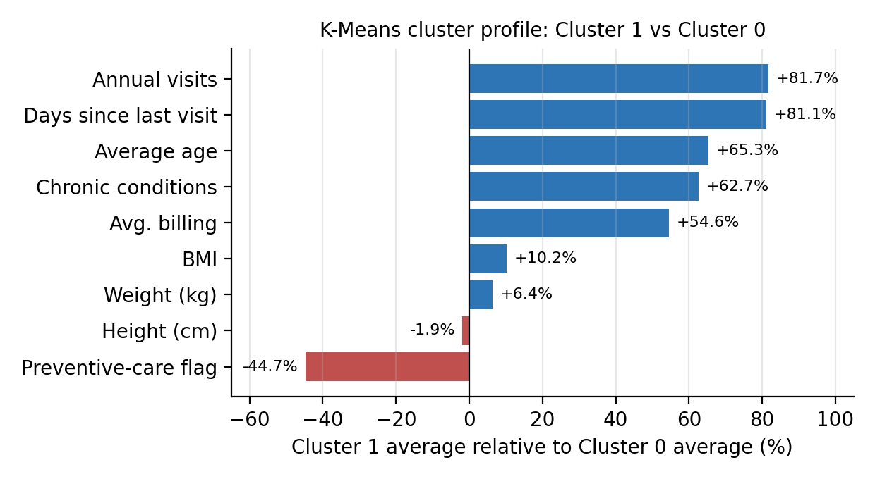
Figure 4.2: Relative difference of Cluster 1 from Cluster 0 for each feature (K-Means)
Interpretation. The Silhouette Scores of 0.1270 (K-Means) and 0.0996 (Hierarchical) are low and close to zero. This means the patient groups have some structure but also considerable overlap, so the clusters should be read as broad, data-driven segments and not as sharply separated clinical categories. K-Means scored higher, which is consistent with comparative EHR studies that rank K-Means first and Hierarchical Clustering second [1], [9]. Both methods minimize within-cluster variance on the same scaled features, so the gap between them is modest.
Cluster profiles. Cluster 0 contains younger patients (average age 35.90 years) with a lower BMI (28.88), fewer chronic conditions (1.42), fewer annual visits (3.12), lower average billing (3420.15) and a shorter gap since the last visit (78.62 days); its preventive-care flag average is higher (0.38). Cluster 1 contains older patients (average age 59.35 years) with a higher BMI (31.82), more chronic conditions (2.31), more annual visits (5.67), higher average billing (5287.43), a longer gap since the last visit (142.36 days) and a lower preventive-care flag average (0.21). Figure 4.2 shows that age, annual visits and days since last visit are about 65 to 82 percent higher in Cluster 1, whereas height differs by only about 2 percent. These labels describe observed data profiles and are not medical diagnoses or treatment recommendations.
Limitations and trade-offs. Because the scores are low, individual patients near a cluster boundary may be assigned arbitrarily, and the two-cluster solution hides finer sub-groups. Height, Weight and BMI are related and may give body measurements extra weight in the distance calculation, and mixing many one-hot columns with numerical features can also blur the separation. Results are reported for a single configuration and have not been validated on external data, so stability across different initializations and values of K should be checked before the segments are used for decisions.

5. Conclusion
This project addressed the problem of grouping patients with similar characteristics when no labels are available. A dataset of 2,000 patient records with 16 features was cleaned using median and most-frequent imputation, one-hot encoding and standardization, and two unsupervised techniques, K-Means and Agglomerative Hierarchical Clustering (Ward), were applied and compared using the Elbow Method, the Silhouette Score, PCA and a dendrogram. Both methods produced two broad patient segments in the tested configuration, and K-Means gave the better Silhouette Score (0.1270 versus 0.0996), making it the preferred model in this study. The profiles distinguish a younger, lower-utilization group from an older group with higher BMI, more chronic conditions, more visits and higher billing, and a lower preventive-care flag. The low scores mean the segments overlap, so they are best used as broad, data-driven groups for analytics, reporting and resource planning rather than as clinical categories.

6. Future Work
- Try other clustering approaches such as K-Medoids, DBSCAN and Gaussian Mixture Models.
- Use clinically richer features (laboratory values, diagnoses, medications) and validated labels where available.
- Explore mixed-data methods such as Gower distance or k-prototypes for numerical and categorical features.
- Add further validity measures (Davies-Bouldin, Calinski-Harabasz) and test stability across K and initializations.
- Apply explainable-AI techniques to describe what separates the segments.
- Build an interactive dashboard for exploring the patient segments.
- Validate the segments on new and external patient data.

7. References
[1] A. Aljohani, “Optimizing patient stratification in healthcare: A comparative analysis of clustering algorithms for EHR data,” Int. J. Comput. Intell. Syst., vol. 17, no. 1, Art. no. 173, 2024, doi: 10.1007/s44196-024-00568-8.
[2] Y. Hu, H. Yan, M. Liu, J. Gao, L. Xie, C. Zhang, L. Wei, Y. Ding, and H. Jiang, “Detecting cardiovascular diseases using unsupervised machine learning clustering based on electronic medical records,” BMC Med. Res. Methodol., vol. 24, no. 1, Art. no. 309, 2024, doi: 10.1186/s12874-024-02422-z.
[3] M. Bampa, I. Miliou, B. Jovanovic, and P. Papapetrou, “M-ClustEHR: A multimodal clustering approach for electronic health records,” Artif. Intell. Med., vol. 154, Art. no. 102905, 2024, doi: 10.1016/j.artmed.2024.102905.
[4] R. Afriany, R. Sinaga, and Samsinar, “Segmentasi pasien berbasis K-Means dari tanda-tanda vital dan demografi: Pendekatan unsupervised learning untuk profil risiko klinis,” J. Ilm. Sist. Inf. Ilmu Komput. (JUISIK), vol. 5, no. 3, pp. 638–650, 2025, doi: 10.55606/juisik.v5i3.1811.
[5] Y. G. Nengsih, K. Samosir, and B. Satria, “Segmentasi pasien rumah sakit berdasarkan pola kunjungan menggunakan algoritma K-Means clustering untuk optimasi layanan medis,” J. Pendidik. Sains Komput., vol. 5, no. 1, pp. 59–69, Feb. 2025.
[6] M. Karaçam et al., “From patterns to prognosis: Machine learning–derived clusters in advanced heart failure,” Front. Cardiovasc. Med., vol. 12, Art. no. 1669538, 2025, doi: 10.3389/fcvm.2025.1669538.
[7] J. Qiu et al., “Deep representation learning for clustering longitudinal survival data from electronic health records,” Nat. Commun., vol. 16, Art. no. 2534, 2025, doi: 10.1038/s41467-025-56625-z.
[8] N. Adhikari et al., “clustra: A multi-platform k-means clustering algorithm for analysis of longitudinal trajectories in large electronic health records data,” arXiv:2507.00962, 2025.
[9] M. D. Samad, Y. Hou, and S. Ghosh, “Mining electronic health records to investigate effectiveness of ensemble deep clustering,” arXiv:2604.07085, 2026.
[10] J. Sim et al., “Using K-means clustering to identify physician clusters by electronic health record burden and efficiency,” Telemed. e-Health, vol. 30, no. 2, 2024, doi: 10.1089/tmj.2023.0167.

Signature of the Guide Course Instructor

